Recognized pattern: FakeDoc_variety1

The form of the pattern:

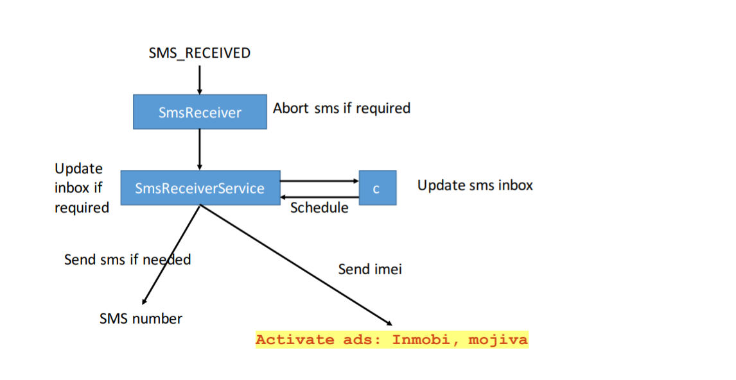

Name of Sample app:

Battery SuperCharger

The name of this app:

F-Droid

For functional modules:

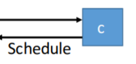

Corresponding to the key code in sample app:

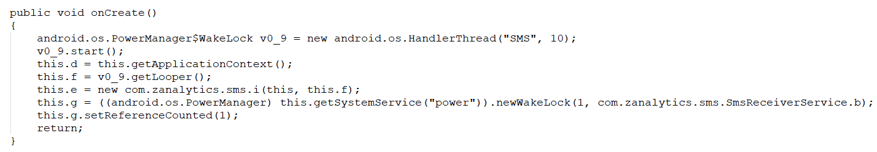

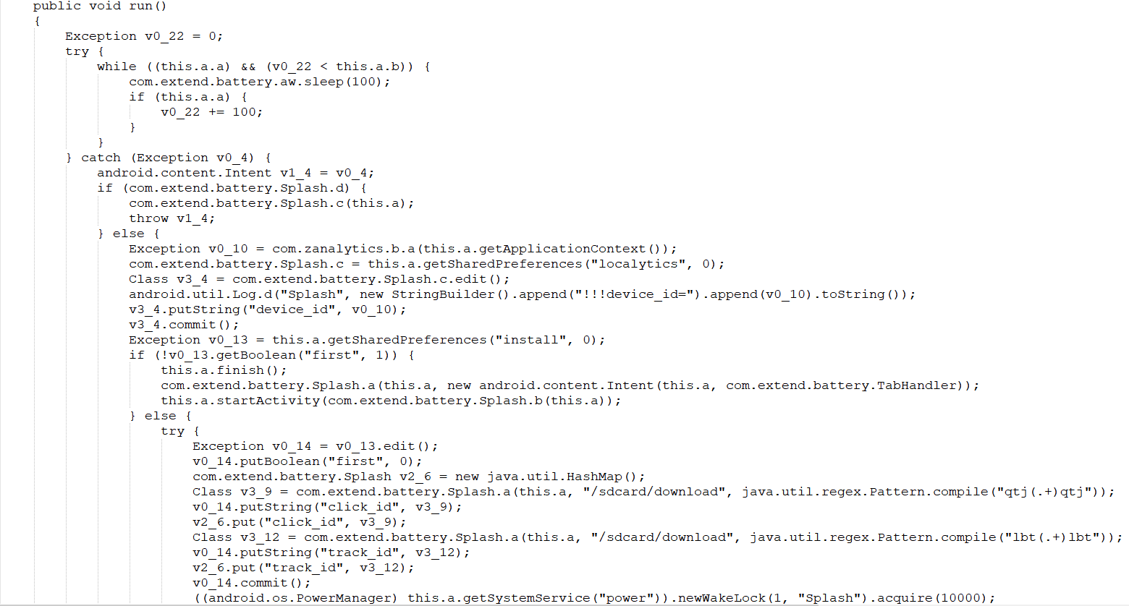

The key code corresponding to this app:

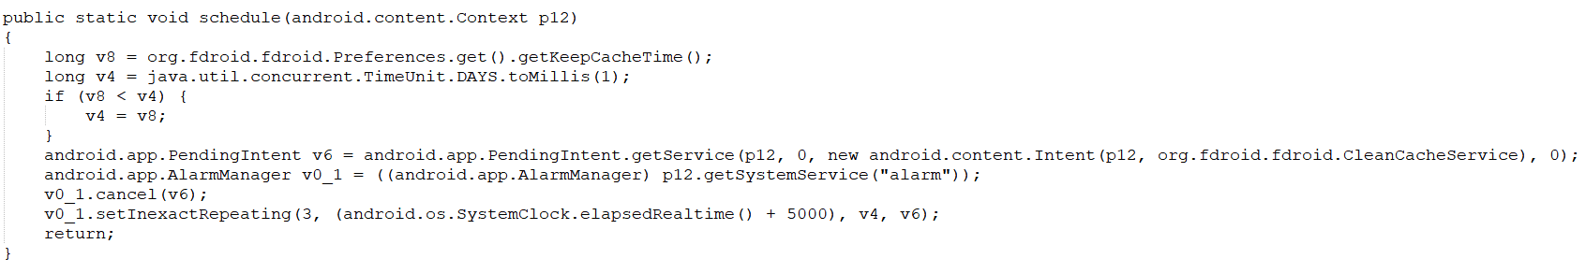

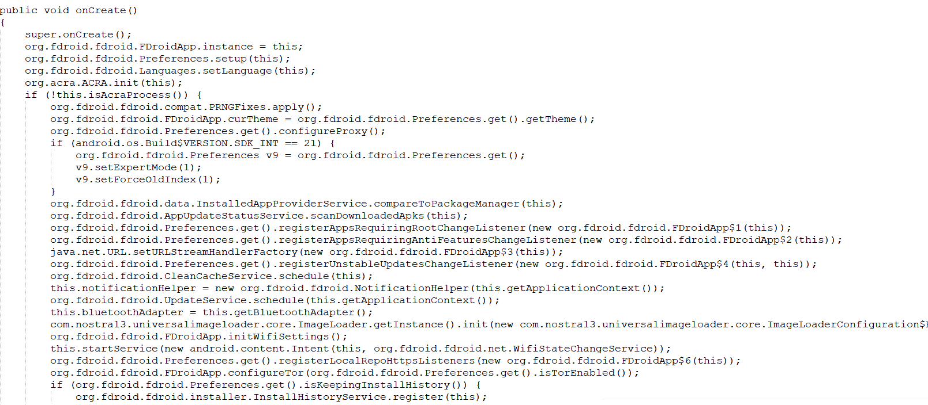

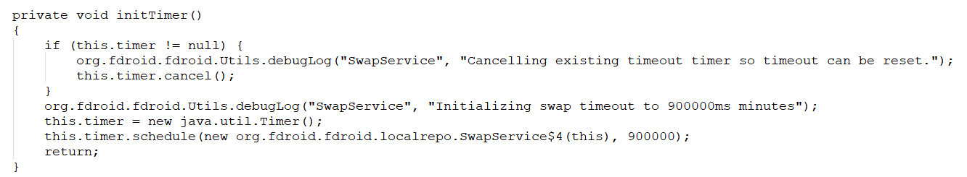

For functional modules (access to personal information):

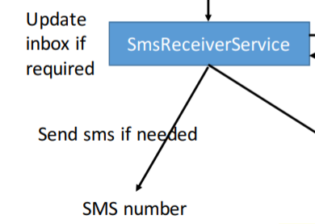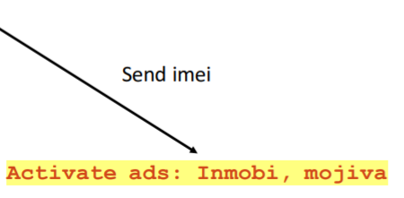

Corresponding to the key code in sample app:

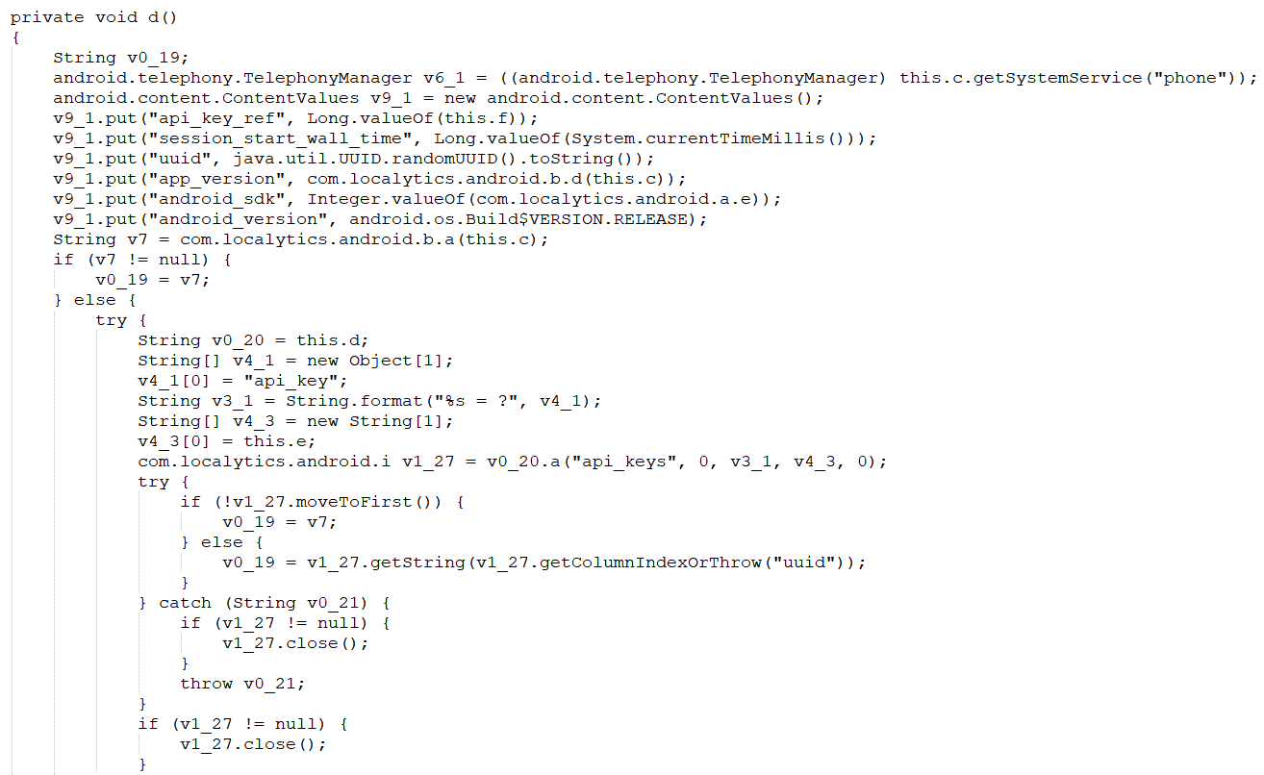

Corresponding to the key code in this app:

